ER Forward Run Tutorial: Buried Metallic Box, Sheet, and Line

Overview
This tutorial builds upon the ER mesh generation tutorials. Users are encouraged to review those examples before proceeding. The jupyter notebook ERT2_mbsl.ipynb takes the user through the steps in this tutorial. The file clear_files.ipynb resets the directory to contain files before running ERT2_mbsl.ipynb. The directory named visit contains the xdmf potential files created using px, and electrode locations for visualization.
The objective of this tutorial is to demonstrate how to use the infinite conductivity boundary modeling capabilities provide by E4D. The primary difference between modeling with and without infinite conductivity boundaries are mesh generation and construction of the survey file. The procedure for generating a mesh with infinite conductivity boundaries is discussed in the mesh generation documentation, and demonstrated in mode_ERT1/mbsl. We begin with the mesh generated in that example, and focus in this example on constructing the survey file and visualizing potential fields. Forward modeling details pertinent to this example are demonstrated in the two_blocks examples.
A cut-out of the mesh generated in mode_ERT1/mbsl, is shown in Figure 1. The surface electrode configuration is the same as that shown in the previous tutorial, and we begin with the survey file for that example (two_blocks.srv) to construct the survey file for this example, which we will name mbsl.srv.

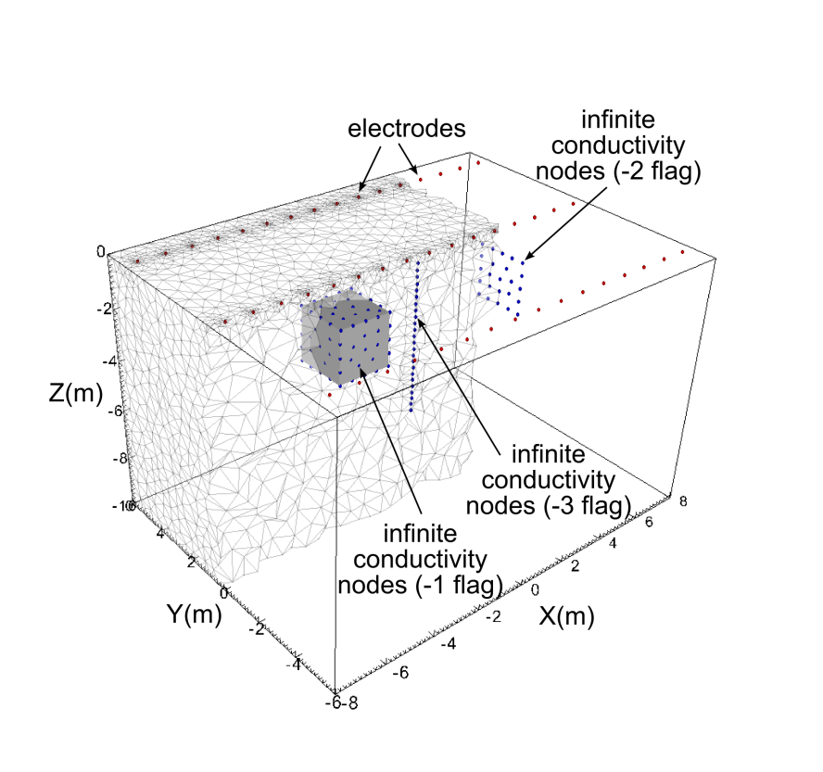
Figure 1. Cut-out view of the mbsl mesh showing nodes added by tetgen for the three infinite conductivity boundaries. The grey region representing the infinite conductivity box is shown for reference.
To enable each of the three infinite conductivity structures to be modeled by E4D, we need to append one electrode for each structure to the end of the electrode block of the survey file. This is required, regardless of whether or not each infinite conductivity boundary is used as a current source, sink, or potential measurement electrode. If no electrode is specified for an infinite conductivity boundary, that boundary will be ignored by E4D, meaning that 3D boundaries will be perfectly resistive (zero flux condition through the boundary), and 1D and 2D boundaries will have no special conditions imposed.
Sections of the survey file mbsl.srv are shown in below to illustrate. Electrodes number 49, 50, and 51 are points on the box, sheet, and line, respectively. These points were taken directly from the mesh configuration file (control points 61, 69, and 125, respectively). That is, since every control point specified in the mesh configuration file becomes a node on the mesh, it is not necessary to search the node file to locate a point on each infinite conductivity boundary. Note that the boundary flag for each infinite conductivity electrode is the corresponding boundary number specified in the mesh configuration file for each infinite conductivity boundary (i.e., -1 for the box, -2 for the sheet, -3 for the line).
Once the infinite conductivity electrodes have been added to the electrode block of the survey file, they may be used as current or potential electrodes just as any other electrode. Measurements 2071 and 2072 show two examples. In measurement 2071 the box (electrode 49) is used as the current source and the sheet (electrode 50) is used as the current sink. The line electrode (electrode 51) is used as the positive potential electrode, and electrode 1 is used as the negative potential electrode. In measurement 2072, electrode 1 is used as the current source and the line (electrode 51) is used as the current sink; electrodes 1 and 2 are used as the positive and negative potential electrodes, respectively.

Survey File: mbsl.srv
<begin survey file mbsl.srv> this line is not included in the file

51 number of electrodes (48 surface electrodes + 3 i.c. boundary electrodes)
1 -7.5 -5 0 1 eind x1 y1 z1 eflag (0 for subsurface, 1 for surface)
2 -6.5 -5 0 1
3 -5.5 -5 0 1
.
.
.
48 7.5 5 0 1
49 -4.0 -1.0 -1.0 -1 this is a node on the box (see control point 61 in mbsl.srv)
50 4.0 -1.0 -1.0 -2 this is a node on the sheet (see control pt. 69)
51 0 0 -0.25 -3 this is a node on the line (see control pt. 125)
2072 number of measurements
1 1 2 3 4 10 1 m_indx a b m n V/I stdev_V/I
2 1 2 4 5 10 1
3 1 2 5 6 10 1
.
.
.
2070 31 47 32 48 10 1
2071 49 50 51 1 10 1 injecting current from box to sheet
2072 1 51 2 3 10 1 injecting from electrode 1 to line

<end survey file mbsl.srv> this line is not included in the file

Potential Distributions for Measurement 2071 and 2072
The simulated potential distributions for measurements 2071 and 2072 were printed to potential files as specified in the output options file (see mbsl.out). Using px, each distribution was added to the xdmf file mbsl.xmf / mbsl.h5, which was created during mesh generation. Figure 2 shows the simulated potential distributions for each measurement as potential isosurfaces. Results above -1 m are clipped to better show the influence of the infinite conductivity boundaries in each case.

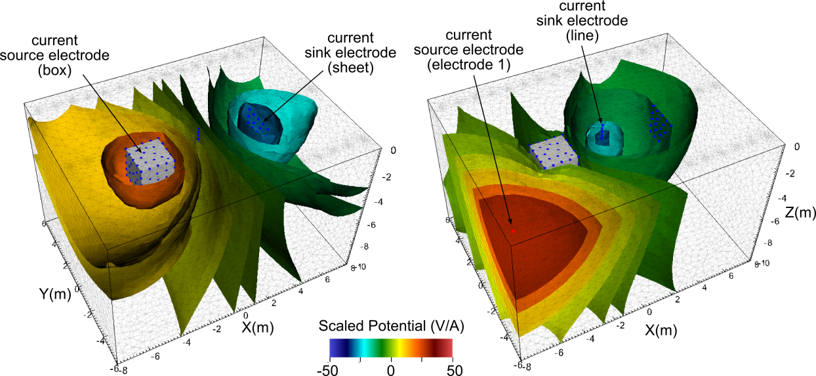
Figure 2. Simulated potential isosurfaces for measurement A) 2071 and B) 2072

